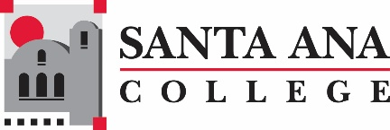

Distance Education Advisory Group Meeting

October 2, 2019

8:00am – 9:30am

SAC, A-101

**Distance Education Mission Statement:**

Our mission in Distance Education at Santa Ana College is to provide our students and faculty with the highest quality distance education program.  We accomplish this mission by assuring that our student coursework provides the depth and breadth of a quality post-secondary degree education while insuring the use of leading edge technology and excellence in teaching.

Agenda

* Spring 2019 Faculty Survey Results
* Current process for Online Faculty Evaluation
  + FARSCCD and Post First process
* Continuing Education OTC – Subset
* Formatting of section comments for Student Clarity
  + On Campus testing
* Topics for Brown Bag Lunch?
  + Discussion Board Topics
  + Student Interaction Techniques
  + Proctoring
    - Required?
    - Proctorio
    - Assessment Centers (SAC, Proctoring Network)
* DE AR: <https://www.rsccd.edu/Trustees/Documents/ARs/ARs-Chapter%204/AR%204105%20Distance%20Education.pdf>
* Any additional topics

Next Meeting, November 6, 2019

***Santa Ana College Mission Statement:****Santa Ana College inspires, transforms, and empowers a diverse community of learners*.